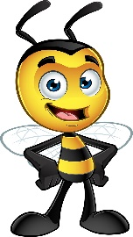 My Favorite Things
Name: Kelly Honn
Grade Level/Position: 5th Grade
Birthday: May 1st
Favorite Foods: Chips & Dip
Favorite Dessert/Candy: Cookies, Ice Cream & Milk
Chocolate or Vanilla: Chocolate
Favorite Drink: Diet Dr. Pepper
Favorite Flower: Lilly
Favorite Color: Purple & Teal
Favorite Sports Team: Royals & Chiefs
Hobbies/Special Interests: Reading, Movies & Crafting
Favorite Restaurants: Jose Peppers, Pearl Tavern & Red Lobster
Favorite Places to Shop: TJ Maxx, Michael’s & Hobby Lobby

