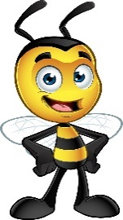 My Favorite Things
Name: Corey Bader
Grade Level/Position: Site Technician
Birthday: March 4th
Favorite Foods: Pizza
Favorite Dessert/Candy:
Chocolate or Vanilla: Vanilla
Favorite Drink: Coffee
Favorite Flower: Tulips
Favorite Color: Blue
Favorite Sports Team: St. Louis Blues
Hobbies/Special Interests: Flying Drones & Roller Derby
Favorite Restaurants: Main Slice, Chipotle & Unk’s Burgers
Favorite Places to Shop: Amazon, Microcenter & IKEA

