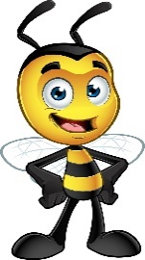 My Favorite Things
Name: Jennifer Eastep
Grade Level/Position: Cafeteria Manager
Birthday: February 5th
Favorite Foods: Nuts & Crackers
Favorite Dessert/Candy: Chocolate & Cheesecake
Chocolate or Vanilla: Chocolate
Favorite Drink: Dr. Pepper
Favorite Flower: Daisy
Favorite Color: Yellow
Favorite Sports Team: Chiefs
Hobbies/Special Interests: Fishing, Gardening, Crocheting, Crafts & Painting
Favorite Restaurants: Longhorn & Applebee’s
Favorite Places to Shop: Hobby Lobby, Old Navy & Bass Pro

